Sources of finance for Film
Crowd funding
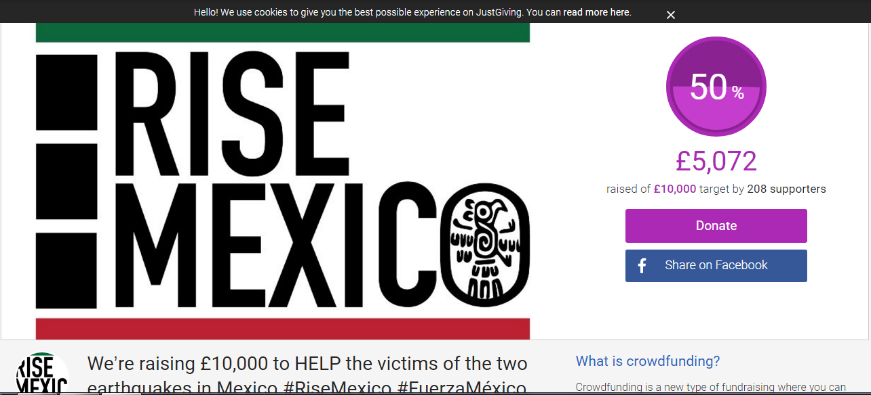
Crowd funding is when a film will ask for money from the people if the ideas are good enough on websites in which people can donate to them. The only thing is with crowd funding is that if the target which you have set for your film is not met within the time limit that you have also put then you will not earn your money and you may have to set another limit to meet and try again. Therefore you have to try and set a limit in which you meet so that you actually get your money for the film and so that you can go ahead with your production and make your film.
Advantages of crowdfunding
With crowdfunding you will be able to set the target and ask for the amount which you think is necessary to make your film with. Another positive is that you will be able to get the funds which have been given to your film straight away and you will be able to access them easier than what you would if you had to get them for yourselves or from the bank. This is also a positive as if you needed to access them from a bank then you would have to pay back interest on your loan which you have taken out so therefore then you would end up losing profit from your film if it was not a success. Also any other money that is donated from people will also is kept from you so that you can maybe add ideas to your film if it wasn’t a good idea and you maybe wanted to make a change to the set or costumes then that money can be kept to spent on that.
Disadvantages of crowdfunding
One disadvantage of crowdfunding is that if you do not make the amount which you have asked for then you will not be able to go through and make your film as you can’t access the money that you need for the film. Another disadvantage is that if the film fails then it will put the business under a massive risk and they will come under the threat of possibly failing and not making the money back in which they put into the project. Another disadvantage of the crowdfunding method is that if there is not a patent or copyright n your idea then it is possible that the idea could be stolen from someone who is looking up for ideas.
My Opinion
In my opinion I believe that crowdfunding is a good option for financing a film as you will be able to set your target and if you believe that your target is a fair amount and other people believe it is a good enough idea then you will most likely be able to promote it to enough people who are able to fund your film and think that it is a good enough idea. I believe that it is also a good idea as you will have to pay no money back with interest and therefore if you make profit on your film then it is most likely that you will make a profit over all as you are expected to pay no money back to anyone apart from actors and producers.
Lottery funding - Government grants
Another source of finance for films is government grants. Government grants is when a number of government run programmes set up accounts which are available to start financing and producing a film. For example if you needed some money to finance your film then you would be able to finance your film from taking a grant out and then financing your film that way as it is much more convenient for a film company to take money out from doing that.
Advantages of government grants
One advantage of using government grants to finance your film is that they provide huge amounts of money which could even reach millions of pounds for your company. For short films this is good as you will not need to take out a large amount of money and therefore they will be more likely to allow you to have the money in which you need to finance your film. Another advantage is that the grants can give your companies instant credibility and more public exposure which is good as more people will be more likely to watch your film and then go and recognise it when it comes out in cinemas. The government also expects no financial return and therefore the company will be able to take their entire grant and use it and possibly even ask for more if needed.
Disadvantages of Government grants
One disadvantage to government grants is that there are strict rules which are in place which you must follow so that you are able to have the money to finance and make the film. This strict guidelines are needed to be followed so that you can get the money otherwise the government could take the money off of you or ask for the remaining amount and then you could be left with half of a film and no money to film the rest of it. If you plan a government grant it will normally require a lot of time and effort as you need to write up the grant and then go ahead and send it off to the government. Another disadvantage is that they are very competitive as other companies will try to match the money which is given to the companies just so they can sponsor the film and possibly make money off whatever money the film makes.
My opinion
In my opinion I believe that using government grants is not a good idea for financing a short film as most of the previous films which they have financed are quite expensive and there is a possibility that they will turn down the chance to make a short film as it doesn’t cost too much money. Therefore if your film does not cost too much money then there is a possible chance that they will decline your approach and ask you to find another company to fund your film. I also believe that government grants are quite bad as you will only get the money in which you ask for when you ask for the money you will not get the money to buy producers and all of the equipment you need therefore it could cost a lot more money than you first originally thought.
Public Funding- The UK film Council
The UK film council is an operation which was set up so that people who were coming up with ideas for films could come and make an idea and then be given the money for the film by the operation and they could fund the ideas which would allow them to come up with the ideas and the right amount of money in which they need to fund the film and set up the set and costumes to go with it. It is also an organisation which has been recommended by many film developers as they can sponsor these films and this will then lead to these films having a main sponsor and they can then promote their film on a wider basis.
Advantages of using the UK film council
One advantages of using the UK film council is that they are known for making and financing films and therefore as they are specialist in doing this most films that are part of this organisation will then go on to become famous and they will then be successful as a film. As they are under a well-known film makers name they are more likely going to be a successful film and will end up having a bigger chance of making profit from there film and not making a loss. Another big advantage of using the UK Film council is that they will always be able to offer the money that you need for your film as they are such a well-known business. Therefore if the film which you are going to make is going to cost a bit more money than what you think it is then you will be able to ask for more money and finance the remaining part of your film.
Disadvantages of the UK Film council
One disadvantage of the UK Film council is that they will only offer about 25-30 percent of the films amount so although you may be able to ask for more they might only offer a little bit more and will not be able to finance the whole film. For example if you needed 5 percent extra money then it is possible that they would not offer that money and you may need to find another source of finance to pay for the rest of the film. Another disadvantage could be that some of the films which have been known to be big films have done very well but most small films do not make it into cinemas and therefore they might feel that it is not a good enough idea to promote and therefore they would have to decline your request and not finance your film.
My Opinion
In my opinion I believe that the UK film council is a good source of finance for a short film and this is because you are putting yourself in the hands of a company who are known for making films and therefore if you needed any help with producing or developing the film then it is more than likely that you will be able to access help from the UK film council and they will then help make your film a success. It is also more than likely that you will be able to go ahead and get all available funding if your film idea is good enough and you can allow them to have a role in producing the film.
Tax Incentives
Another source of financing for a film is tax incentives. A British tax incentive is a copyright claim that can be sold to a British film company which could raise more money which will be spent on your film. For example film production companies will contact the British tax incentive and ask for additional funds which will allow their company to earn a small amount or large amount of money which will be able to be used to finance the film and then you will be able to go ahead to make the film. The most money that can be given by the British Tax incentive is 10 Million Pounds extra money than what they already have available.
Advantages of Tax Incentives
One advantage of using the Tax incentives is that if you need any extra money to build an area in which the place you are filming does not yet have then you will be able to ask for more money from the money you get with tax to then build the new area and set with so they could actually be forced to give you extra money if you need it. Another advantage is that it will be able to increase film tourism around the world and more money could go to other countries however the tax which you ask for is also part of the money what is needed if you go to another country in filming.
Disadvantages of Tax Incentives
One disadvantage of using tax incentives is that they will result in undesirable inequities. Another disadvantage is that they may bring about unintended windfalls of rewarding firms for not using the incentives. For example if a business has not used an incentive then it is more likely that they were under the finance of a big firm who is able to finance the whole film rather than getting a tax incentive to pay for the whole film. This could mean that they are more likely to get famous film which will be available to watch in the cinemas and on DVD’s.
My Opinion
In my opinion I believe that tax incentives are a bad source of finance for a big film. This is because they will more than likely ask for most of the money back and therefore this could mean that you could end up paying double the amount for your film to be produced and this would then mean that all of the money made could be spent on the refunding and also if the film fails you could be spending your own money in trying to pay back all of the money.
Private Investors
Private investors are funds which are available from an individual who is looking to add risk to their portfolio and maybe even make a higher net worth than what they believe they could make if they went into a company and asked for the money. Any of the capital funding which is needed will be provided by the individual and may come from private equity (private individuals and funding groups) or debt financing (finance institutions or banks). The main elements of this include things like marketplace analytics, audience analytics, a bondable schedule and budget, and a distribution plan.
Advantages of Private investors
One advantage of a private investor is that if the film is a success then there is more chance of the individual who has put all of this money into the business to make more profit off the movie if it is a successful film as they have had no other financing source and therefore they will not have to give any percentage of the money which has been made to any other financing company and therefore they will keep most of the profits apart from the ones which they will have to give to actors and directors of the film. Another advantage is that they will be more likely to make a profit even if the film fails as they may not put a large amount of money into the film as it is only a short film and they don’t normally cost that much. Therefore every short film which uses this financing technique will be more likely to make a profit anyway.
Disadvantages of Private Investors
The biggest disadvantage of private investors is that it is a big risk for the person who invested all of the money into the film. This is because if the film fails then they will end up having no money left if no profit is made as the main reason they put all of this money into the business is because they target to make a bigger net profit than what they would if they asked a film company to invest. Another disadvantage is that they might need a bit more money than what they first imagined and therefore they would have to go to the bank to this money and therefore they would need to pay interest on their bank loan. This could therefore mean that the cost of the bank loan could be a lot if you don’t pay it over time.
My Opinion
In my opinion I believe that private investors are a good source of finance for short films as it is more than likely they will be able to invest in your film as they are known for making short films and this would mean that you are in good hands when it comes to producing and developing your film to become the best it can be. They are also much more likely to accept your idea as they can also help with the developing of the film and they might be able to get a bit more money out of making the film.
Joint financing - BFI Film Industry
The BFI film agency is a leading film agency in the UK which has donated £26 million throughout the years to help develop and produce films. It also helps with the development of making films and also will help with co-productions in the UK. A main reason why the UK film industry has been so successful is down to their helping of all types of films such as short films and long films which end up being featured in the cinema.
Advantages of using the BFI film industry
One advantage of using the BFI film industry is that they have in the past helped all types of films including short films and that will be helpful as they have not had many films which have failed. Another advantage is that they have donate over £26 million which is good for short films as they don’t normally need much budget to them and therefore they will not need much money to produce the film therefore the BFI Film industry will be willing to give the money across.
Disadvantages of using BFI film industry
One disadvantage of using the BFI film industry is that they will need to have a good idea to be able to produce the film as they will only fund the ideas which they believe are very good and are good enough to be able to make profit for the company and therefore they will have to make sure that the idea is good enough so that they will sponsor and fund your film. Another disadvantage is that they might turn down a request just for funding as they might want to actually be involved in the production of the film and therefore they might also ask for a producer slot and therefore they would not be the best company to ask to fund your film as they will need to make sure they are involved somehow.
My Opinion
In my opinion I believe that the BFI film industry is a bad source of finance for short films as you may not be able to make your idea as they may want to put some input in with your ideas and therefore they will try to ruin the ideas in which you have come up with and this could be unhappy actors and original producers as their ideas have been tampered with. This could therefore be the only downfall for most companies as they might not be happy with having their original ideas broken up just because they want a bit of business in your film.

